Numerical Simulation and Spectral Analysis of a Microwave Signal for Frequency-Domain Characterization Using Spectrum-Analyzer Concepts
Aim:
To simulate a microwave signal and analyze its frequency spectrum using numerical methods and spectrum-analyzer concepts to determine its frequency components, bandwidth, and spectral characteristics.
Procedure:
- Open MATLAB or suitable signal-processing simulation software.
- Generate a microwave signal with a specified carrier frequency, amplitude, and sampling frequency.
- Introduce noise or additional frequency components to study their effects on the signal spectrum.
- Apply the Fast Fourier Transform (FFT) to convert the time-domain signal into the frequency domain.
- Plot the frequency spectrum and analyze the carrier frequency, harmonics, bandwidth, and noise components.
- Emulate a spectrum analyzer by displaying signal power versus frequency and evaluate the spectral characteristics.
Code:
clc;
clear;
close all;
%% 1. INPUT PARAMETERS
fc = 10e9; % Carrier frequency = 10 GHz
A = 1; % Carrier amplitude = 1 V
fm = 0.1e9; % Modulating frequency = 0.1 GHz
mu = 0.5; % Modulation index = 0.5
fs = 50e9; % Sampling frequency = 50 GHz
%% 2. TIME VECTOR
Tsim = 200e-9; % Simulation duration = 200 ns
N = round(fs*Tsim);
t = (0:N-1)/fs;
%% 3. GENERATE AM SIGNAL
% Standard amplitude modulation
m = cos(2*pi*fm*t);
carrier = A*cos(2*pi*fc*t);
signal_AM = A*(1 + mu*m).*cos(2*pi*fc*t);
%% 4. TIME-DOMAIN PLOT
% Display first 5 ns for clear visualization
idx = t <= 5e-9;
figure;
plot(t(idx)*1e9,signal_AM(idx),'b','LineWidth',1.2);
grid on;
xlabel('Time (ns)');
ylabel('Amplitude (V)');
title('Time-Domain AM Microwave Signal');
%% 5. FFT SPECTRAL ANALYSIS
Y = fft(signal_AM);
P2 = abs(Y/N);
P1 = P2(1:floor(N/2)+1);
P1(2:end-1) = 2*P1(2:end-1);
f = fs*(0:floor(N/2))/N;
% Convert voltage amplitude to dBV
P_dBV = 20*log10(max(P1,1e-12));
%% 6. FREQUENCY SPECTRUM
figure;
plot(f/1e9,P_dBV,'LineWidth',1.3);
grid on;
xlabel('Frequency (GHz)');
ylabel('Amplitude (dBV)');
title('Single-Sided FFT Spectrum of AM Signal');
xlim([9.5 10.5]);
%% 7. IDENTIFY CARRIER AND SIDEBANDS
f_lower = fc-fm;
f_upper = fc+fm;
fprintf('\nMICROWAVE SIGNAL SPECTRAL ANALYSIS\n');
fprintf('---------------------------------\n');
fprintf('Carrier frequency : %.2f GHz\n',fc/1e9);
fprintf('Carrier amplitude : %.2f V\n',A);
fprintf('Modulating frequency : %.2f GHz\n',fm/1e9);
fprintf('Modulation index : %.2f\n',mu);
fprintf('Sampling frequency : %.2f GHz\n',fs/1e9);
fprintf('Number of samples : %d\n',N);
fprintf('FFT frequency resolution: %.2f MHz\n',fs/N/1e6);
fprintf('\nEXPECTED SPECTRAL COMPONENTS\n');
fprintf('Carrier frequency : %.2f GHz\n',fc/1e9);
fprintf('Lower sideband : %.2f GHz\n',f_lower/1e9);
fprintf('Upper sideband : %.2f GHz\n',f_upper/1e9);
%% 8. THEORETICAL AMPLITUDES
Ac = A;
Aside = mu*A/2;
fprintf('\nTHEORETICAL AMPLITUDES\n');
fprintf('Carrier amplitude : %.3f V peak\n',Ac);
fprintf('Each sideband amplitude : %.3f V peak\n',Aside);
fprintf('Each sideband relative to carrier: %.2f dBc\n', ...
20*log10(Aside/Ac));
%% 9. POWER DISTRIBUTION
% Assuming a 1-ohm reference resistance
Pc = Ac^2/2;
Psb = Aside^2/2;
Ptotal = Pc + 2*Psb;
fprintf('\nPOWER ANALYSIS (1-ohm reference)\n');
fprintf('Carrier power : %.4f W\n',Pc);
fprintf('Each sideband power : %.4f W\n',Psb);
fprintf('Total AM signal power : %.4f W\n',Ptotal);
%% 10. SPECTRUM NEAR CARRIER
figure;
plot(f/1e9,P_dBV,'r','LineWidth',1.3);
grid on;
xlabel('Frequency (GHz)');
ylabel('Amplitude (dBV)');
title('Detailed Microwave Spectrum');
xlim([9.8 10.2]);
hold on;
xline(f_lower/1e9,'--k','Lower Sideband');
xline(fc/1e9,'--b','Carrier');
xline(f_upper/1e9,'--k','Upper Sideband');
%% 11. AM ENVELOPE
envelope = A*(1 + mu*cos(2*pi*fm*t));
figure;
plot(t*1e9,envelope,'r','LineWidth',1.5);
hold on;
plot(t*1e9,-envelope,'r','LineWidth',1.5);
grid on;
xlabel('Time (ns)');
ylabel('Amplitude (V)');
title('Theoretical AM Envelope');
xlim([0 50]);
fprintf('\nSimulation and spectral analysis completed.\n');
Output:
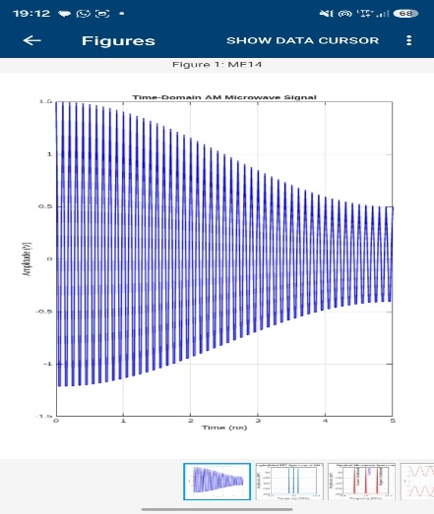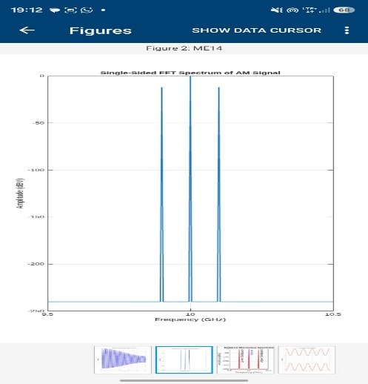
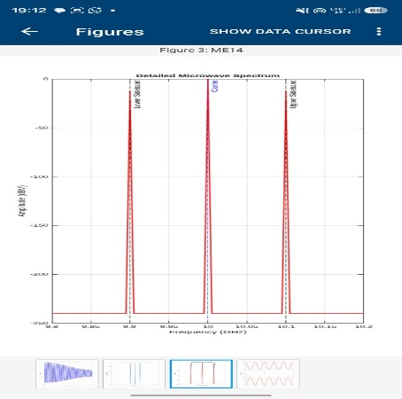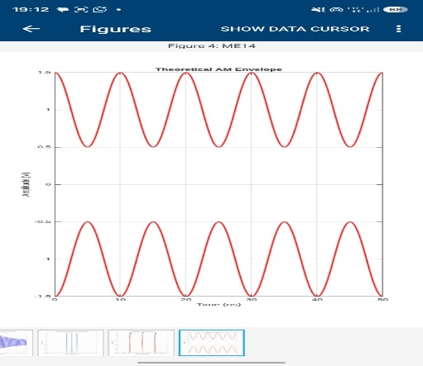

Result:
The microwave signal was simulated successfully, and its frequency spectrum was analyzed using FFT and spectrum-analyzer concepts. The carrier frequency, frequency components, bandwidth, and noise characteristics were identified through frequency-domain analysis.

